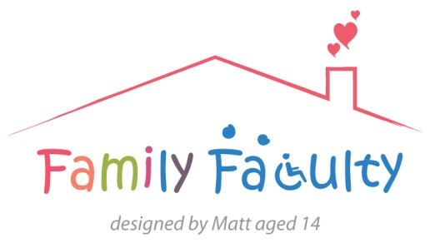
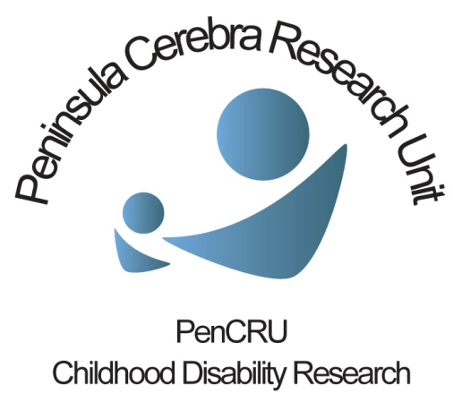

Oral Health and Dentistry meeting
Thursday 13th February 2014 10am-1pm
Present: Julia, Tricia, Julia, Sheri, Peter, Zoe Allen, Cara Ball, Cathy Coelho, Ian Mills, David Moles, Mona Nasser, Meghan McCrory, Chris Morris
5 members of the Family Faculty, 6 professionals, 2 members of the PenCRU Team
Apologies: Eight other parents had sent apologies but wished to be kept informed.

Introduction
Last year PenCRU produced a ‘What’s the evidence?’ summary around the theme of oral health and dentistry in response to a question from a parent. The process of producing this summary highlighted the significance that dental issues have to many members of our Family Faculty (FF). Several parent carers were unable to attend the meeting and had emailed ideas/experiences.
The purpose of this meeting was to bring together colleagues from dentistry, PenCRU researchers and parents to see if there is shared interest around potential research projects relating to oral care and dentistry. CM also mentioned the present opportunity arising from the NIHR call for research relating to children/young people with long term conditions www.themedcalls.nihr.ac.uk/children
Following the introductions, parents were interested to know how dentists had been recruited for this meeting. CM and DM explained that those present were colleagues that they already had links with, although we are inclusive and other Dentists could also be invited to future events.
CM asked about challenges that parents have experienced related to dentistry and oral care. Below is a summary of the discussion that followed, and research opportunities that emerged.
Long waiting lists and multiple referrals
Parents and dentists discussed delays in referral and treatment that families of disabled children had experienced. The group tried to identify if there was a knowledge gap that could be addressed by research that may help with this challenge, or if this was due to a service resource limitation.
One area that emerged was improving communication between dentists and families of disabled children. There was a shared experience in the group that had the dentist been clear why a child might be referred to different specialists and clearer explanation of the rationales for this, and how long the process was likely to take, would improve experience of care.
Another suggestion for research to address the issue of waiting times and multiple referrals was to develop a case study to find successful dentist practices, or dentists, who are able to manage the system and families’ expectations and find out what makes them successful in doing so.
We also discussed challenges identifying and managing oral pain in children. However, the group felt that preventing the likely causes of oral pain was perhaps a more important priority to study.
Exclusion and access to dental services
Many in the group felt that inclusion should be improved for disabled children to access dental care.
One issue was accessibility and availability of information regarding oral care and dentistry for parent carers. Many of parents didn’t have access to information that they felt was needed and would like research see what other parents and carers use an information sources.
Several parents within the group said that they have been given the impression by professionals that dental care is ‘the least of your worries’, in light of their other medical conditions. Furthermore, parents in the group discussed that they experienced a vast difference in the quality of care offered to their neuro-typical children verses their disabled child. Dentists in the group agreed with the parents comments, and said that as a profession they aren’t getting access to children early enough.
It was the experience of both the dentists and parents in the group that despite disabled children requiring oral care and dental support when they are young, dentistry often isn’t seen as a priority by other health professionals who are caring for the child. The group felt that dentistry should be regarded of higher importance when considering the overall health of a child, and that signposting to appropriate information and services could be improved.
Research ideas that came out of this discussion were a project looking at where parents are able to access information around oral hygiene and dental care for children with disabilities, and who is or could/should be responsible for providing advice on this aspect of health care.
Another idea discussed was a project to find out if there is any evidence that the experiences of exclusion and unfair access discussed in the group are representative of the wider population, perhaps in the form of a review and wider consultation/mapping exercise.
A suggestion was made to develop and evaluate an educational intervention, such as producing an information resource specific to improving oral hygiene in children with disabilities.
Outcomes
Measuring the impact of interventions on oral health was identified as difficult, because the impact of poor oral health happens over a long period, a full dental examination can be difficult to arrange, and even then can be difficult to quantify. There is also a survey already being run to compare the oral health of disabled children verses that of neuro-typical children.
This led onto a discussion of how outcomes are measured in dental research. Oral health-related quality of life questionnaires are commonly used. Research to identify what outcomes are important to parents and professionals may be helpful. There was also discussion that there may be scope for a systematic review of existing questionnaire tools that are used to measure outcomes. PenCRU have been involved in two projects that may be relevant to this approach (www.pencru.org/projectsmeetings/projects/title_305733_en.php and www.pencru.org/projectsmeetings/projects/title_305749_en.php)
It was discussed that satisfaction of the child being treated and their family are rarely measured.
Better communicating what goals/outcomes a parent and dentist are seeking to achieve from a dental appointments and care was identified as another area that research may seek to improve.
Communication
The issue of the need to improve communication between dentists and children/young people and parents/carers was something that underlined many of the concerns raised by the group. Communication was also raised as an issue in its own right. ‘What more as a parent can I do to help?’ was a question raised in response to repeated experiences whereby dentists failed to listen to advice parents had around treating their child.
Experience shared within the group demonstrated that despite parents having many practical tips and useful knowledge around ways to encourage children to withstand treatments, dentists in the past had not asked, or in some cases event listened when informed. Parents also found that even when going to see a specialist dentist these problems persisted. Dentists in the group explained that even though some dentists are specialised, may not be naturally empathetic or have an insight into the best methods of communication to use. It was suggested that parent feedback would be helpful and that research to help address this gap would be beneficial.
It was discussed that PenCRU have developed a similar project to improve communication within hospitals that may be relevant: www.pencru.org/projectsmeetings/projects/title_305748_en.php
The group felt that developing an intervention with key messages to improve communication would be extremely helpful. Other avenues for research that were suggested were to find out what mechanisms dentists use at present to request feedback from patients and their families.
Research idea summary
Measuring outcomes of oral care/dentistry in children with neurodisability, reviewing appropriateness of oral health-related quality of life questionnaires uestionnaires.
Preventing the likely causes of oral pain in children.
Where parents access information around oral hygiene and dental care for children with disabilities, and who is or could/should be responsible for providing advice on this aspect of health care.
Survey consultation/mapping exercise regarding experiences of dental care for disabled children.
Improving communication between dentists and children/young people, and families generally.
Next Steps
The dentistry colleagues who attended the meeting shared their thanks and continued interest in working with PenCRU.
The minutes will be circulated to the group (including people who were interested but unable to attend) for comments.
MM is consulting disabled children and young people on their experiences and ideas related to teeth, oral care and dentists as part of activities to engage children in research.
CM/DM to discuss next steps for collaborative oral health and dentistry research.

