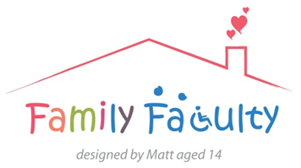
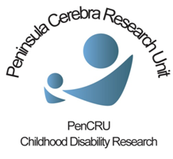

Involving Children and Young People in PenCRU
17 November 2014
Veysey, Room 006

Present: 8 x Family Faculty -Tricia, Julia, Kirstin, Bel, Mike, Sam, Jane, Harriet
3 x PenCRU – Katharine, Sharon, Anna

Apologies: 5 x Family Faculty – Rosy, Clare, Hilary, Ursula, Ruth
Introduction
Katharine gave an update on work towards the project so far.
Suggested next stage

Attendees were asked their opinion on plans to offer the opportunity to a small group of young people (ideally 3) between the ages of 16-24 to attend 3 meetings in February/March 2015 to work on a specific task to produce a resource to share the findings of the hospital communications project with other children and young people. Attendees also looked at a mock-up poster to advertise this opportunity to young people, and application and information forms for the young people to complete.

Feedback

3 meetings:
- Will a 2 hour session be long enough to explain what needs to be done and then achieve something worthwhile each time?
- Maybe it would be more productive to fill 1-2 whole days. With a possible fun activity offered at the end of the session (swim or games of some kind).
- Discussion on whether more suitable to schedule over the weekend/holidays or if it could be done during school time with support from the young person’s educational establishment if relevant. It was agreed schools/colleges should be keen for their pupils to participate and may be able to supply enablers etc. too.

Selection:
Meeting
- A pre-project meetings meeting/open day as an open invitation to all young people to come along and find out in person what we are looking for from their input. There should be some actual tasks to complete which will feed into the main group’s later work, and will be acknowledged (certificate or similar) as a valuable contribution to the end product.
- Young people will be able to complete the application forms at this event, with assistance if required, and PenCRU will be able to check young person’s level of ability in person if a parent has completed the form for them.
- Important to manage the young people’s expectations sympathetically. Be clear all input is valued at the Open Day stage even if not selected for the working group and offer opportunities to feedback again on finished product at the end.
- This method works well to identify C&YP who may be interested in becoming involved with PenCRU on an ongoing basis, if not part of the main working group on this occasion.
Forms
- The application and ‘About me’ forms are too long and detailed.
- Need to provide clear instructions that they can be written out by someone else but do need to be the young person’s own answers to the questions.
- Remove ‘disabled’ label in instances where it relates to the participants rather than the research study task as not all young people will be aware it applies to them.
- There should be a form with information and parental consent as well as one for the young people. Parents/carers are better to ask about parking permits, and specific support needs should be asked of both young people and carers to check that they match up.

Advertisement
- Focus is currently on ‘research’ but this is not what we are actually asking the participants to do.
- Should be asking if people are good at communicating information, working in a team, helping other people with additional needs etc. (This should also be reflected in the application form questions –‘ what have you done that shows you can do x,y,z?’)
- Mike works with groups of young people that may be able to take on the task of redesigning the advertisement posters to make them more graphically appealing to other young people.

Practical considerations:

- Do parents/carers need to be asked to consent to their C&YP being involved?
- Are young people able to give their own consent – how can we check each individual’s understanding?
- Need to be aware of who is responsible for the young person during the meeting. Will a parent/carer be required to remain on site? Insurance etc. needs to be considered. What happens if the young person loses interest and wants to leave early?
- What additional support can we actually offer? Braille etc.
- We should provide recognition for the C&YP involved – acknowledgement in cash is not acceptable but high street vouchers are an option. Would this just be for the working group? How could those participating in ground work at the open day be acknowledged?

