
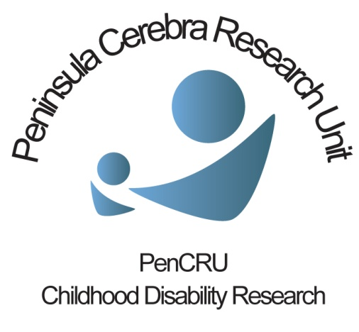
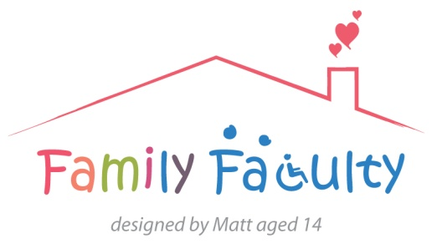

Healthy Parents Project meeting
03/04/2014 Veysey Building
Family Faculty: Kirsty, Julia, Mary, Tricia PenCRU staff: Chris, Meghan, Val
Overview
In this meeting we:
Told the group about a recent meeting we had with colleagues in psychology
Discussed the changes they suggested to how we were thinking of designing the project
Used post-its to make a new “model in progress” to work from
What next?
We have 3 weeks after Easter to submit our application to the Medical Research Council so it is unlikely that we will have another full meeting, but we will be asking for your input via email.
The next step is for Chris and Val to pull together everything we have discussed and write a first draft of the application. We will then circulate to the group for comment and suggestion.

At our last meeting, we showed you a slide with a sketch of an intervention that would try to help people change aspects of their own health behaviour.
We thought that working as a group with information and support and using techniques such as goal setting this would lead to changes in people’s health behaviour and at the same time, improvement in their psychological well being.
When we met with our colleagues in psychology they were concerned that:
- If everybody had different things that they wanted to change, what exactly would be delivered in the sessions? The same material/guidance is unlikely to cover all needs (unless you have everyone working towards the same goal, such as weight loss).
- If everybody had different things that they wanted to change (e.g. smoking or exercise), then how could we measure change, and change in what exactly?
- As these would be almost individually tailored interventions, then the research would be impossible to replicate.
Instead, they suggested a change of focus:
- Instead of focussing on whether health behaviours have changed as a result of the intervention and trying to measure that, what we should measure is whether the intervention is successful to empower people to identify a desire to make a change to some health behaviour and feel able and confident to make their own plan to do that. This could be measured in the same way for everybody.
- Working as a group, building on support and a shared sense of identity, the various group activities would aim to create these ‘conditions for change’ by which a parent carer could make changes in their own life.
- The first stage of the research could be a series of group meetings to try out different activities and discuss how people felt about doing them and whether they thought they were useful.
We discussed these ideas at the meeting on the 3rd. We also talked a lot about the make-up of the groups that might participate in the intervention, in several specific ways:
- How would we advertise and who to?
- Who would come to the meetings? There is a difference between getting the invitation out to people and them engaging in the activity. Even if people identified it as something for them they may not feel empowered to do it “almost like you have to do the course to know you have to do the course!”
- Issues around safeguarding, confidentiality and screening for potential clinical mental health needs.
- Potential conflicts within the groups and the need for procedures to manage this.
We identified several objectives for this early development research:
- Look at how to advertise the opportunity and recruit people
- Look at what sort of screening processes ensure that this is an appropriate activity for that person (e.g. people who may participate because they see it as a means to getting something else; people who may have more serious clinical problems and need signposting to relevant services)
- Explore different activities that the group might do as part of the intervention; discuss what people think about these activities, whether they are useful, how they could be done differently
We used post-its to make a visual representation of all of the things we discussed. This is shown on the last page.
- Working from the left of the page are some of the factors that you have told us are barriers to being as healthy as you would like (the list is not exhaustive!)
- The next column shows some of the things we will have to consider regarding how we advertise the group and who might make up the groups.
- In the circle are the things that will be going on during the intervention. Some of these things are activities, such as goal setting; others are about organising the groups, such as safeguarding; others are about the processes at work and things that might change through being part of the group, such as developing a shared social identity, raising awareness of ones self-identity and increase in self worth.
- Towards the right of the page are some of the things that the research would hope to achieve; creating what are called conditions associated with change – empowering people to identify their own needs and the best ways for them to tackle them.

This is still very much a work in progress and we would value any comments or suggestions you have.
Causal factors
Societal,
Lifelong responsibility,
adequate support, service provision etc
Anger

Anxiety/ depression

Lack of confidence

Sleep deprivation

Guilt at taking time for self

Present/ post?
PTSD

Social isolation

Stigma

Selection +
Screening for M.H. clinical issues
Recruitment
Who?
How to advertise?
What to call it?
Reach vs engagement – is it for me?
Contextual factors: rural vs urban, socioeconomics, parent/child characteristic
Different stages of journey
Quality of life

Wellbeing

Life satisfaction

Knowledge:
Of a thing
Of you
Of a situation

Social participation

Doing things with children
Children as a focus for change
Within group norms

Social support

Behavioural intervention

Homework

Conditions associated with change

Self-identify self-worth

Goal setting

(non-judgemental)
acceptance
Shared social identity

Build resilience

Boundaries and rules

Understanding causal factors influences on health
Managing stress and stressors
Political prejudices

Safeguarding issues

e.g. identifying best times of day for exercise

Barriers: group dynamics; not productive; break ups – how to manage
Independent and group self-esteem and social value
Physiological markers of ability to cope with stress
Motivation

Self-efficacy / locus of control

Empowering people to identify their own needs and ways to tackle them
Resources to help make change: specific to the behaviour and to parent carers

