

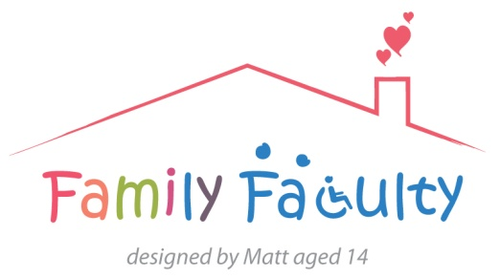

Sleep positioning systems project meeting
08/07/2014 Veysey Building
Family Faculty: Julia, Kirstin, Alan PenCRU: Sharon, Katharine, Chris
Other colleagues and visitors: Jo (Evidence Synthesis Team), Sarah (Chailey, by teleconference)
Apologies: Sarah, Catherine, Sharon (Family Faculty), Morwenna, Katrina, Ginny and Stuart (Other)
Overview
In this meeting we:
- Gave an update on the Cochrane review and interpreted findings
- Gave an update and discussed the feasibility randomised controlled trial led by Chailey
- Discussed a further review on the literature about sleep positioning systems
The Cochrane systematic review
- The search for studies looking at sleep positioning systems for children with Cerebral Palsy has finished and we are now interpreting the results.
- The inclusion criteria for this review are strict. Only RCTS (randomised controlled trials) are considered of a scientific standard to be included.
- The primary outcome that we looked at was whether night time postural management systems reduce hip migration for children with cerebral palsy. Secondary outcomes included i) Sleep quality, ii) Pain, iii) Respiratory Function. Very little evidence had been found.
- The Cochrane review challenges assumptions that there is a robust evidence-base for sleep positioning systems, and generated discussion about information provided to families.
- As the Cochrane review only looks for RCTS, Jo’s team are now planning to undertake a further non-Cochrane review which will include other types of studies.
The feasibility study
- There has been a difficulty in recruiting research sites and recruiting/retaining participants, and there has been substantive methodological learning through conducting the study.
- The present trial will finish in autumn 2014 with a report to follow.
Non-Cochrane review
- Jo asked for comments about the Draft Protocol released for the non-Cochrane review.
- Discussion focussed on setting PICO-structured question for the review including: i) Population - should the focus be cerebral palsy or broader to encompass neurodisability? ii) Intervention - should the review be contained to night-time sleep postural systems or lying supports generally and/or other equipment used in 24 hour postural management? iii) Comparison - are there any relevant alternatives? iv) Outcome - What is the primary purpose of the intervention and what other outcomes are relevant and important to consider? How to capture experiences of families using equipment and any challenges/adverse outcomes.
Discussion points:
There were several points raised in relation to the 3 studies mentioned above:
- Issues/challenges associated with using the sleep systems included child and parent sleep disturbance, using other medical technology alongside the sleep system (e.g. wires/tubes being tangled in the system), and managing wind/gastro-oesophageal reflux. These challenges can be considered in the non-Cochrane review through including any relevant qualitative studies.
- Discussion considered whether sleep systems are prescribed as a conservative treatment for hip subluxation (partial dislocation of the hip). It was suggested that they are prescribed in this way for younger children but may be prescribed to improve quality of sleep/reduce pain for older children. A sleep system may also be used following surgery to maintain the hip. It was noted that early hip surgery is now commonly preferred over delaying orthopaedic surgery.
- Parents mentioned that they primarily used the sleep system for postural management as part of a 24 hour postural management programme and assumed it was used just as much for support and protection for the spine as the hips. It was discussed that separating out sleep systems from other support equipment used as part of 24 hour postural management in research is important.
- It was discussed whether the non-Cochrane review should focus on night time ‘sleep positioning systems’ or lying supports used during the day and/or night. Stakeholder group to be consulted.
- The parents also mentioned that they were concerned about not using the sleep system correctly and that parents might not be given the training and support needed. While one parent liked the versatility of rolls and cushions of the sleep system and it worked well for their child, another parent found their child fights the sleep system and their child did not sleep as well in the system.
- It was suggested that qualitative studies should be included in the non-Cochrane review to capture staff and parents’ experiences of using the sleep systems.
- It was agreed that the scope of the non-Cochrane review should be broadened to children with any neurodisability using a sleep system. Stakeholder group to be consulted.
- It was agreed that the non-Cochrane review should include studies on children and young people from 0-25yrs in line with new SEND guidelines. Stakeholder group to be consulted.
Next steps:
- Jo will make changes to the Draft Protocol for the new review and send out to the group (including writing a plain language summary to include at the beginning).
- Discuss the questions raised at the meeting with the wider stakeholder group
- The next meeting will likely be in the Autumn

